

**NMAM INSTITUTE OF TECHNOLOGY**

(A unit of Nitte Education Trust)

Nitte - 574 110, Karkala taluk, Udupi Dist., Karnataka

**Department of Computer Science and Engineering.**

**RDBMS PROJECT REPORT ON**

**COLLEGE BUILDING ARCHITECTURE DATABASE.**

***PROJECT ASSOCIATES***

**Ashika S Shetty Anusha Jagannath Soorenji**

**4NM17CS032 4NM17CS027**

**V Sem, Sec 'A' V Sem, Sec 'A'**

**Dept of C.S.E Dept of C.S.E**

**PROJECT GUIDE**

**Mr. Roshan Fernandes**

**Dept of C.S.E.**

**NMAMIT**

**ABSTRACT**

NMAMIT is a very huge college. Freshers find difficulty in locating their classrooms and labs. So, college building architecture website is useful in solving this problem.College building architecture is a website where students can directly access their classroom address and lab address through internet.Students are also given provision to locate staffrooms of a particular faculty.This website is usually available 24 hours a day. So it is very convenient for the students. One of the most important feature of this site is that it saves lot of time in locating any rooms in the college during exams.

**TABLE OF CONTENTS**

**Chapter Page no.**

**1. CERTIFICATE 4**

**2. ACKNOWLEDGEMENT 5**

**3. INTRODUCTION 6-9**

**4. PROBLEM STATEMENT 10**

**5. DATABASE DESIGN 11-12**

**6. FRONT END TECHNOLOGY 13**

**7.BACK END TECHNOLOGY 14**

**8.SCREENSHOTS 15-19**

**9.CONCLUSION 20**

**10.REFERENCES 21**

**CERTIFICATE**

Certified that the project work carried out by Ashika S Shetty (4NM17032) and Anusha Jagannath Soorenji(4NM17CS027) bonafide students of NMAM Institute of Technology, Nitte in fulfilment for the Relational database Management System lab in Computer Science and Engineering during the academic year 2019-2020.

Signature of the Examiners:

Signature of the Guide:

1.

2.

**ACKNOWLEDGEMENT**

The satisfactions that accompany the successful completion of any task would be incomplete without the mention of the people who made it possible. So we acknowledge all those whose guidance and encouragement served as a beacon of light and crowned our efforts with success.

We are thankful to our project guide, Mr. Roshan Fernandes, Dept. of CSE for his valuable guidance and advice. His willingness to motivate us contributed tremendously to our project.

We would like to place on record our deep sense of gratitude to Dr. K. R. Udaya Kumar Reddy, HOD-Dept. of Computer Science and Engineering, NMAMIT, Nitte for his generous guidance, help and useful suggestions. We also acknowledge and express our sincere thanks to our beloved Dr. Niranjan. N. Chiplunkar, Principal, NMAMIT, Nitte who is a source of inspiration to us.

We thank all the Teaching and Non-Teaching staff members of the department of CSE for providing resources for the completion of the project. A special thanks goes to our parents, friends and relatives for supporting and encouraging us in all ways thus making our project

successful. Finally, we thank all those who have contributed directly or indirectly in making this project a grand success.

Ashika S Shetty Anusha Jagannath Soorenji

(4NM17CS032) (4NM17CS027)

**CHAPTER 1**

**INTRODUCTION**

INTRODUCTION

1.1 Problem Definition:

NMAMIT is a college with vast campus surrounded with greenary. It is a tedious task to find any classrooms or labs for freshers and for the people who visit our campus for certain occasion. Also students find difficulty in locating staffrooms.

In real world people find difficulty in locating places.This problem is solved with the help of google maps.Also in college students find it difficult to locate their classrooms during exams if the campus is vast. Students even find it difficult to approach concerned faculty. One can get full information about the classrooms, labs and concerned faculty with the help of college architecture database. If one wants to find his/her classroom no need to dependent on others or no need of running around the campus in search of their classroom,they can simply use this website to get the appropriate location of their classroom or labs or any faculty.This website is user friendly and responsive.

DEFINITION OF STUDENT PREFERENCE:

Student preference refers to, “how students access services available in college architecture site to locate their classrooms, and labs over network”.

WHAT IS STUDENT PREFERENCE?

Student generally prefer that site should be reliable and flexible. If these requirements are available then there is increase in demand of usage of this site.

USAGE OF SITE:

Generally students using this site should have internet facility and valid data.If the student is familiar with the place then he/she can save the details and that detailes can be accessed by others. Even the college can use this site to allot classrooms to students during examination,they can just do it by entering the approriate information and then click on modify to make the changes.

THE DOs AND DONTs IN COLLEGE BUILDING ARCHITECTURE WEBSITE:

If people want to use this website online, enjoy finding proper locations , then they should follow a few basic Do’s and Don’ts while accessing this websites.

DOs:

* Always try to enter the information regarding the address in this website.
* Always enter valid address in this site because others can access those data.If the data entered is invalid then that person might be in trouble.
* Always enter valid detailes about alloting the classroom during examination

DON’TS:

* Do not enter wrong detailes in this site.The detailes should be cross verified .
* Do not enter wrong detailes regarding the classes allotted during exams.
* Do not forget to inspect the data that is entered int this website.
* Do not enter the detailes with lack of knowledge.If the students find that detailes entered is wrong they should inform to the concerned authority immediately.Students should be confident about the detailes entered in this website.

**CHAPTER 2**

PROBLEM STATEMENT

Finding the detailes of each and every classrooms and labs is also a tedious task.This website identifies the gap between current state and required state.There is a lot of effort made in gathering the detailes of classrooms,labs and staffrooms so that data should be consistent.

SYSTEM STUDY

EXISTING SYSTEMS:

The present study has made an attempt to understand the student’s problems . So this gave an idea for the development of college building architecture project.

At present every college website gives information regarding their current activities and infrastructure.In addition to that college building architecture website gives complete description about each and every classroom location.Students can get to know about their seating arrangement not on the day of exam but prior to that.This website gives complete detailes about faculties.

OBJECTIVES OF THE STUDY:

The objective is of this project is to design an dynamic website.

FUNCTIONAL REQUIREMENTS:

1.System should allow to save the detailes

2.System should display the detailes

3.Search the detailes efficiently

4.System should update the detailes.

NON FUNCTIONAL REQUIREMENTS

1.Optimal speed

2.Reliable

3.Maintainable

4.Available

5.Responsive

6.Inexpensive

7.User-friendly

**CHAPTER 3**

**ER-Diagram**

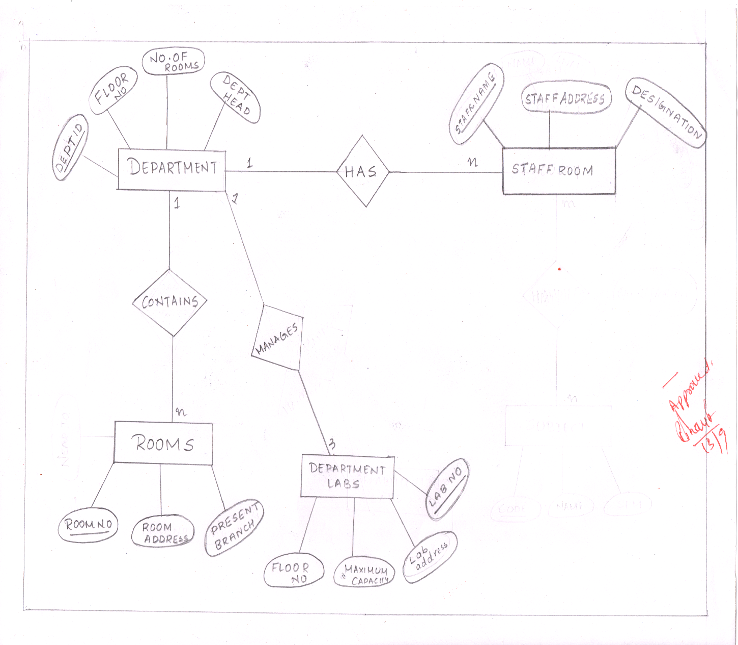

**SCHEMA**

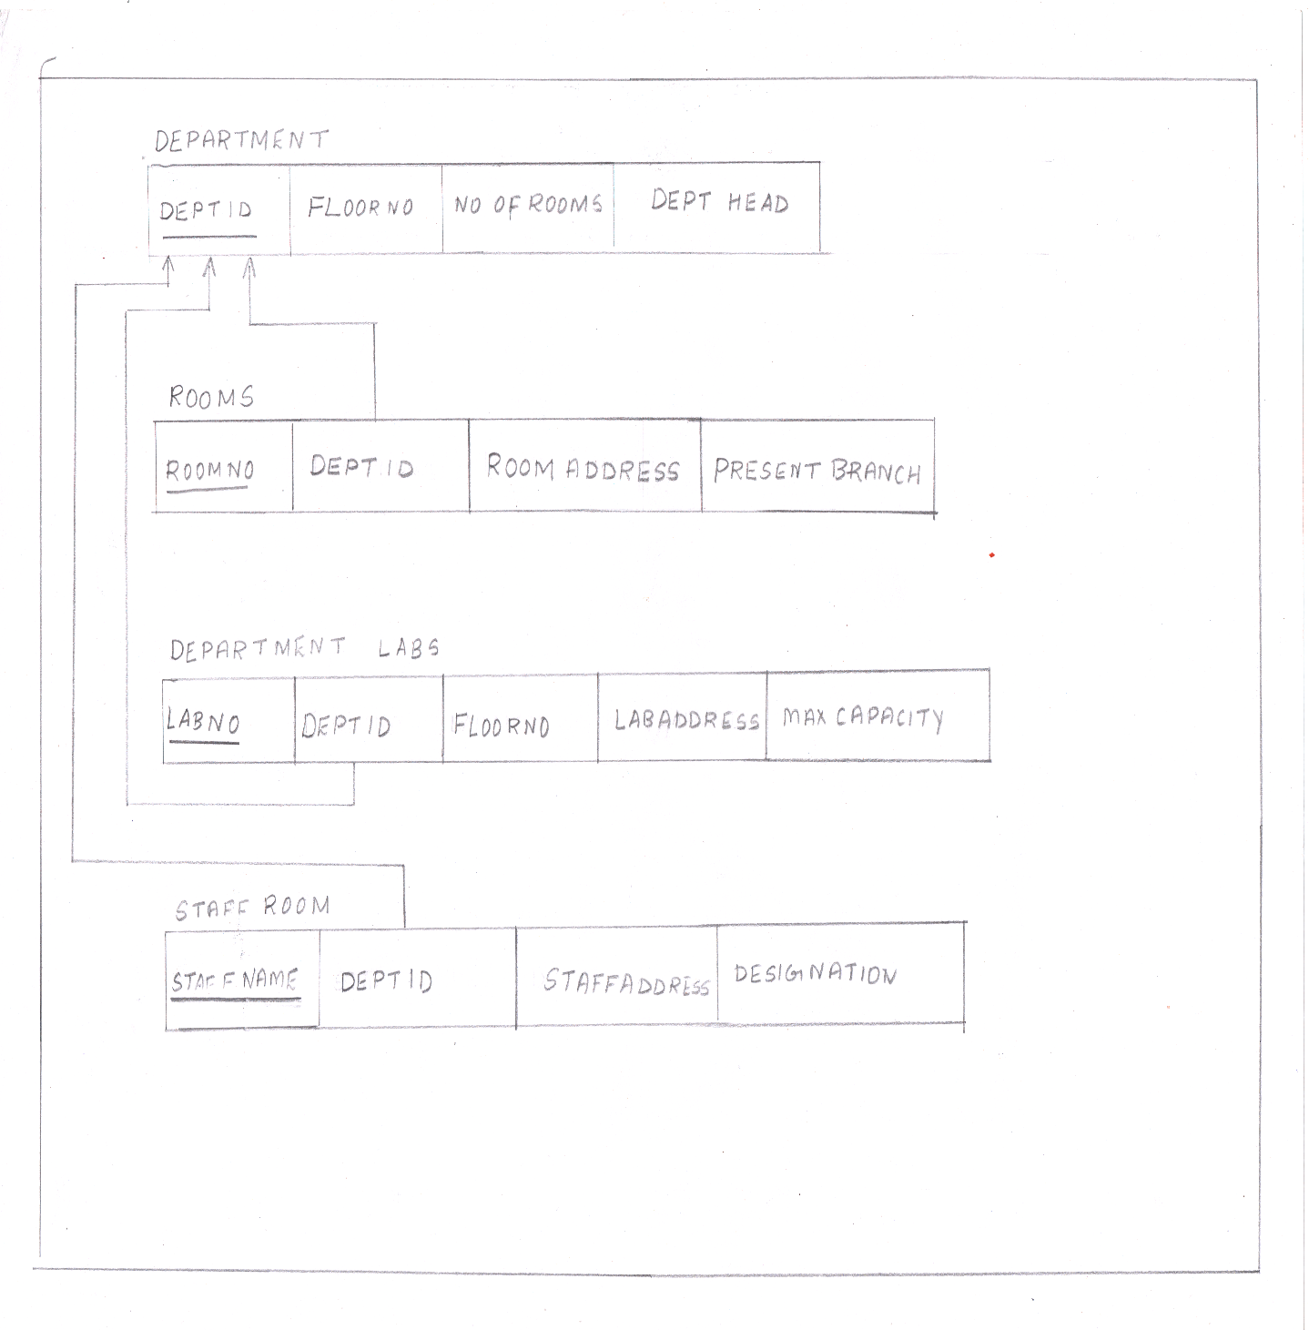

**CHAPTER 4**

**FRONTEND TECHNOLOGY**

**List of technologies for frontend**

**1. Hyper Text MarkupLanguage(HTML)**

Hypertext Markup Language is the standard markup language for creating web pages and web applications.

**2. Cascading Style Sheets(CSS)**

Cascading Style Sheets is a style sheet language used for describing the presentation of a document written in a markup language like HTML

**CHAPTER 5**

**BACKEND TECHNOLOGY**

**List of technologies for Backend**

**1.PHP**

Hypertext Preprocessor is a server-side scripting language designed for Web development, and also used as a general-purpose programming language. It was originally created by Rasmus Lerdorf in 1994, the PHP reference implementation is now produced by The PHP Group.

**Database:**

**phpMyAdmin:**

phpMyAdmin is a free web application that provides a convenient GUI for working with the MySQL database management system.It is the most popular MySQL administration tool that is used by millions of users worldwide and has won numerous awards and honours.

**Chapter 6**

**SCREENSHOTS**

**HOME PAGE:**

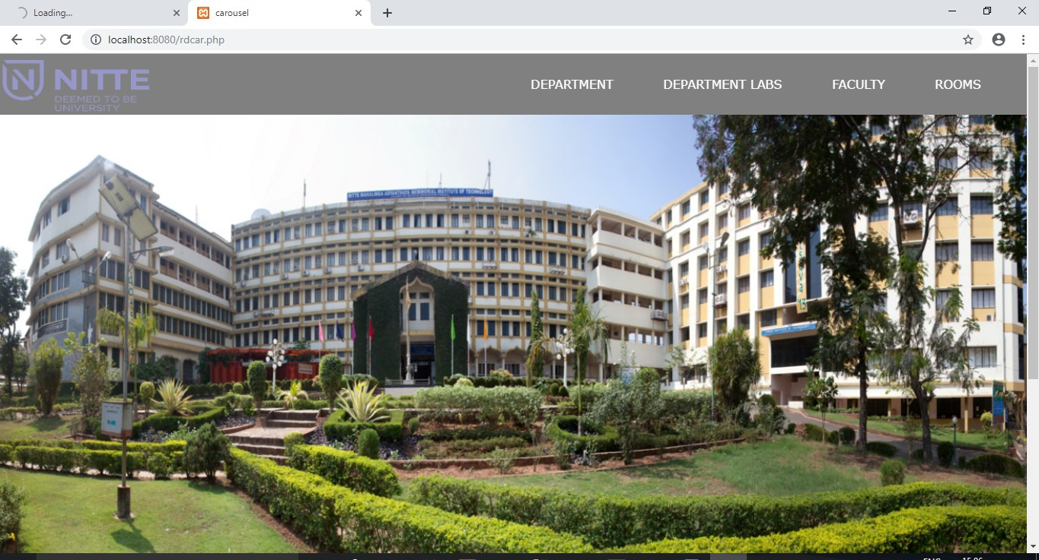

**DEPARTMENT PAGE:**

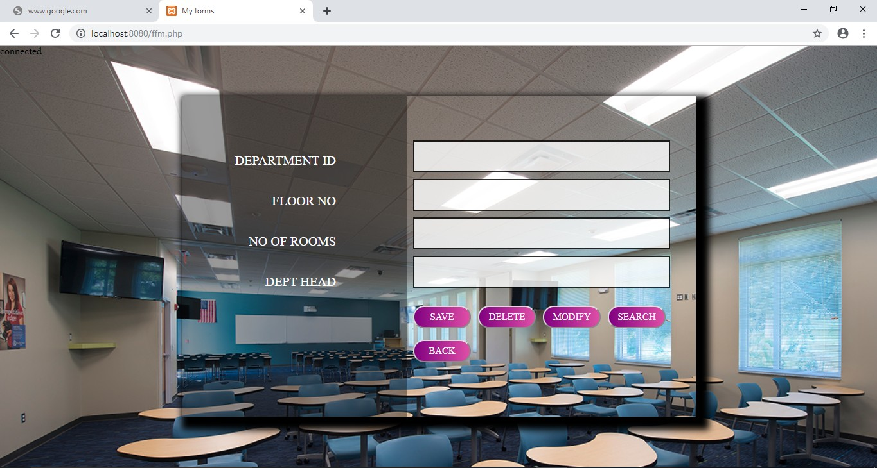

**DEPARTMENT LAB PAGE:**

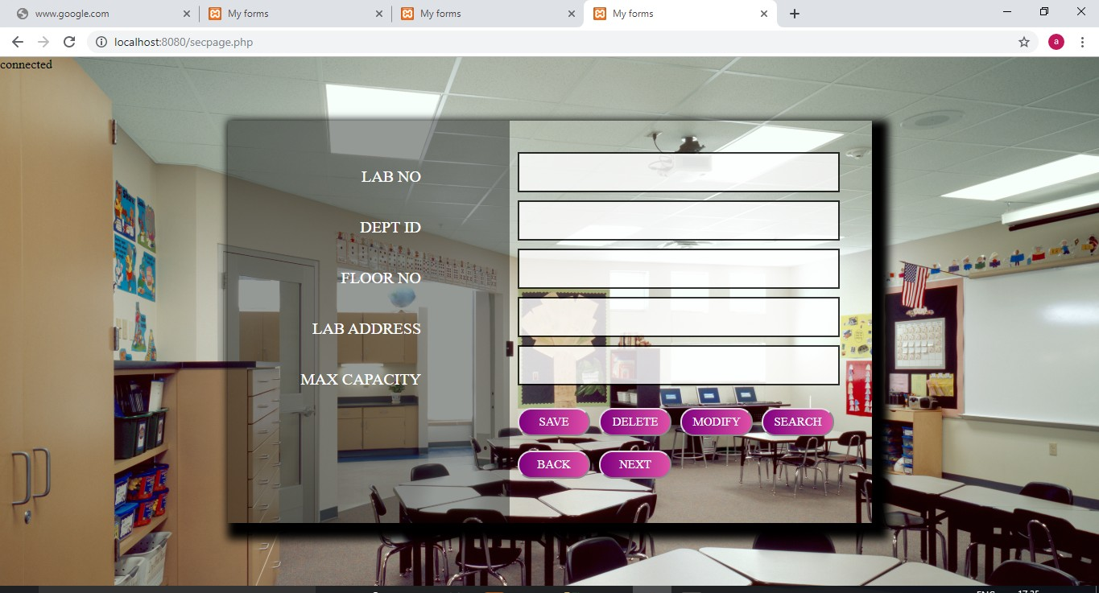

Shows the most popular items on Tienda.

**STAFFROOM PAGE AND ROOM PAGE:**

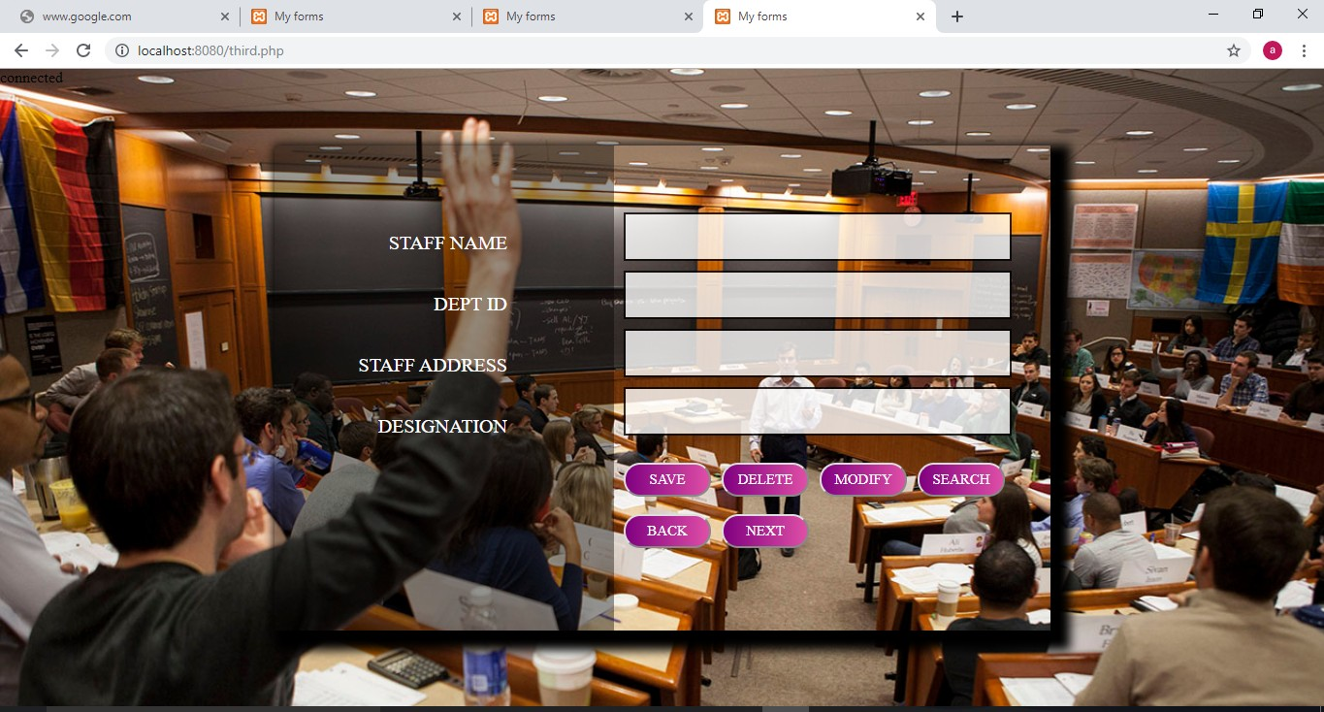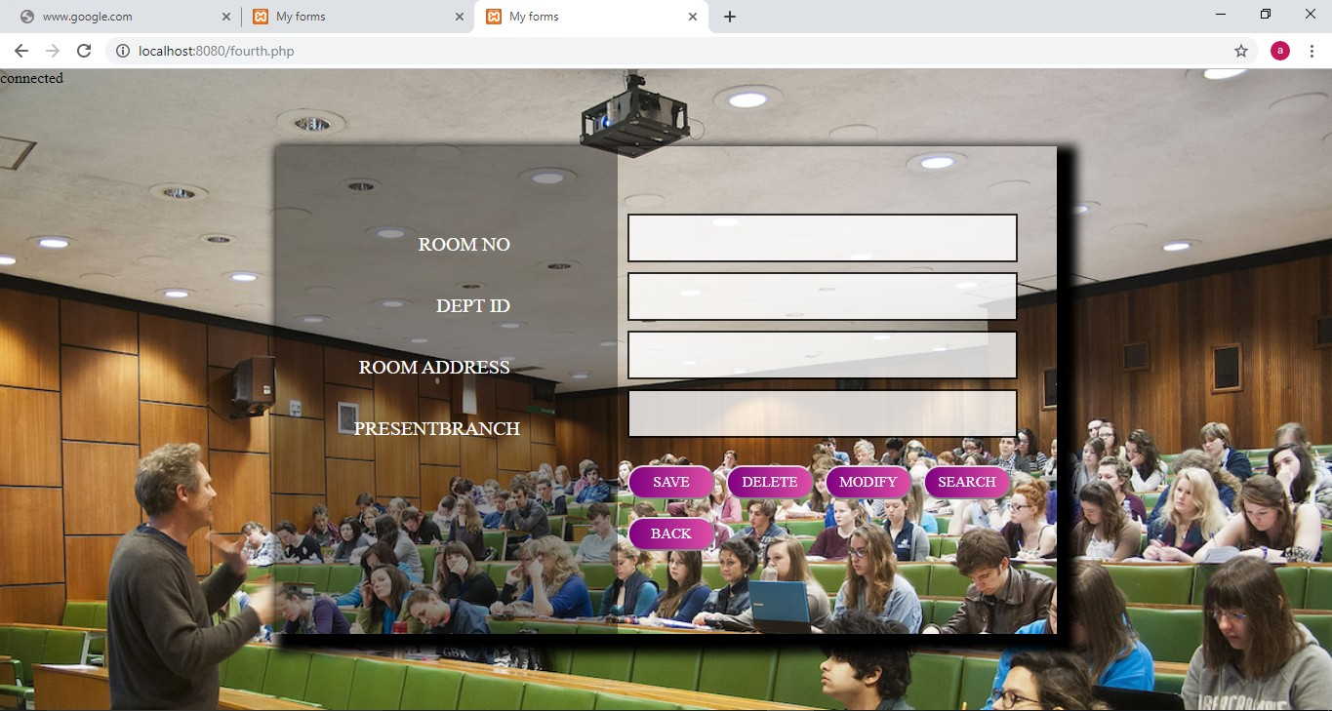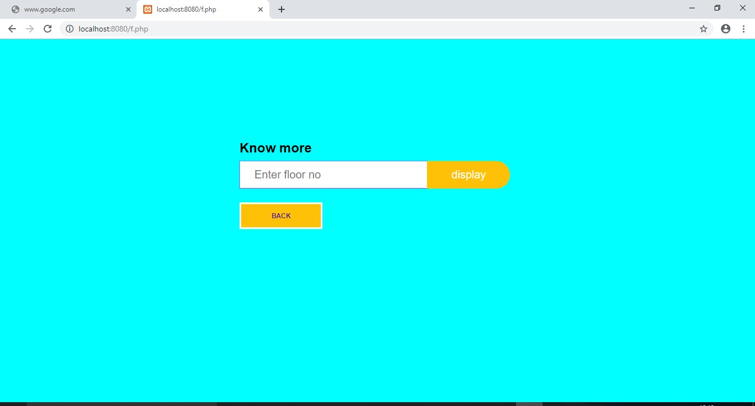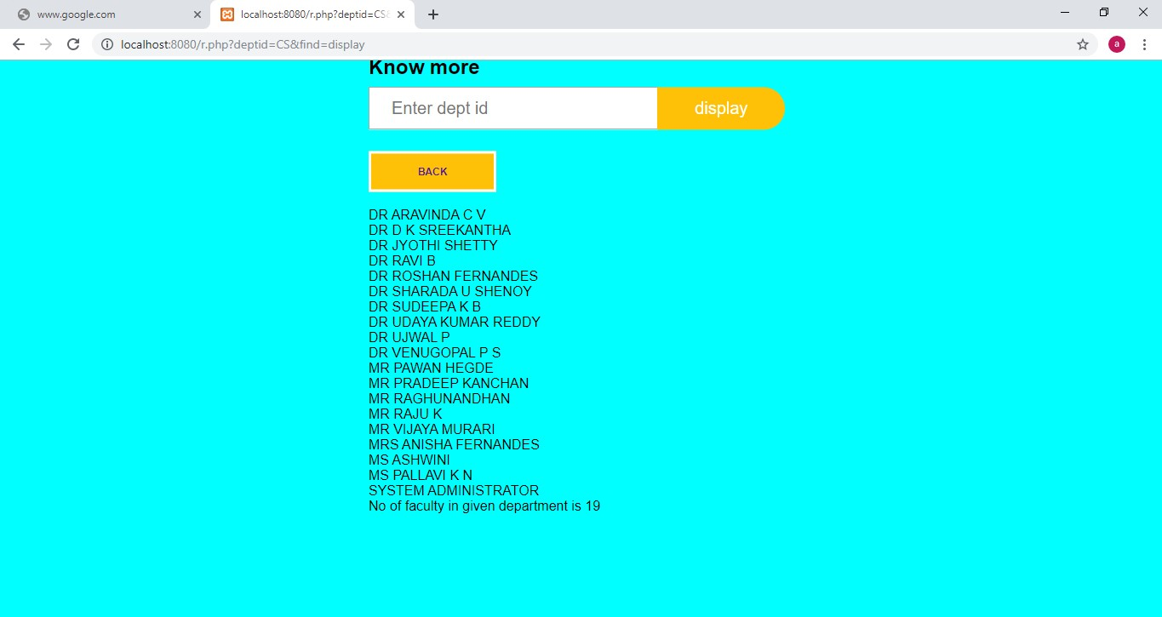

View the department labs and faculty detailes.

**IMAGE TAKEN WHILE CONDUCTING THE SURVEY OF COLLEGE:**

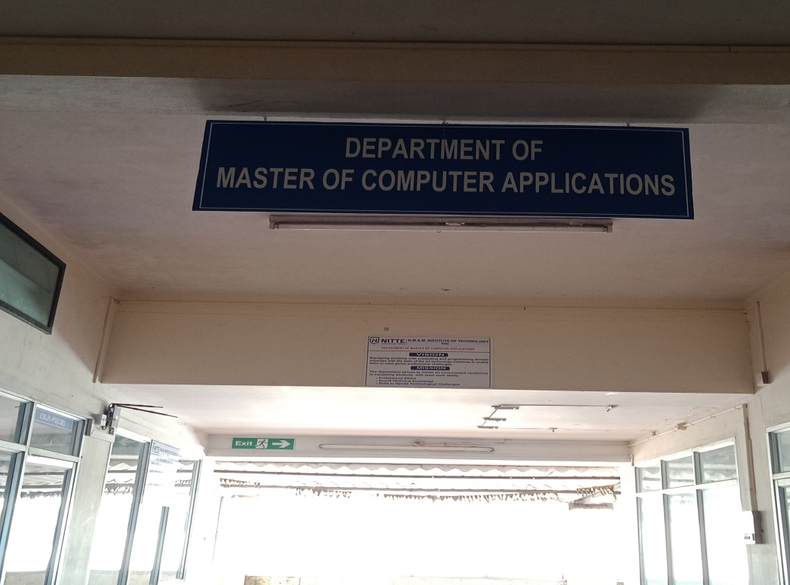

**CHAPTER 7**

**CONCLUSION**

The “**COLLEGE BUILDING ARCHITECTURE WEBSITE**” is successfully designed and developed for fulfilling the necessary requirements as the system is very much user friendly, form level validation and field level validation are performing very efficiently. The present project has been developed to meet the aspirations indicated in the modern age.

**COLLEGE BUILDING ARCHITECTURE WEBSITE** allows to store class- rooms ,labs and faculty detailes.

The survey has been conducted in the college in order to gather the information regarding the classrooms ,labs along with faculty details. This software package allows storing the details of all the data related to college architecture. The system is strong enough to withstand operations under conditions where the database is maintained. The implementation of the system in the organization will considerably reduce data entry and time.

**CHAPTER 8**

**REFERENCES**

**1.** [**www.stackoverflow.com**](http://www.stackoverflow.com)

**2.** [**www.youtube.com**](http://www.youtube.com)

**3.** [**www.w3schools.com**](http://www.w3schools.com)